CYCLE-2

1. Create a three dimensional array specifying float data type and print it.

PROGRAM:
import numpy as np
arr = np.array([[[1, 2, 3], [4, 5, 6],[4, 5, 6]], [[1, 2, 3], [4, 5, 6],[4, 5, 6]],[[1, 2, 3], [4, 5, 6],[4, 5, 6]]], dtype='f')
print(arr)

OUTPUT:
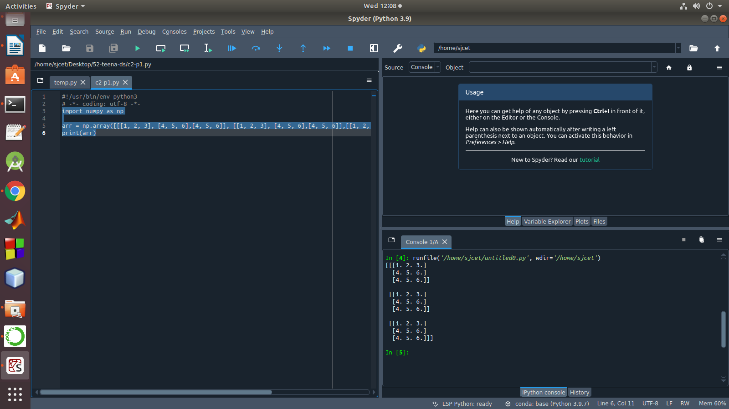

2. Create a 2 dimensional array (2X3) with elements belonging to complex data
type and print it. Also display
a. the no: of rows and columns
b. dimension of an array
c. reshape the same array to 3X2

PROGRAM:

import numpy as np

arr = np.array([[[1, 2, 3], [4, 5, 6]]])
print(arr)
#a
numOfRows = np. size(arr, 0)
print("rows:",numOfRows)
numOfColumns = np. size(arr, 1)
print("columns:",numOfColumns)
#b
print("Dimension",arr.shape)
#c
rs=np.reshape(arr, (3, 2))
print(rs)

OUTPUT:

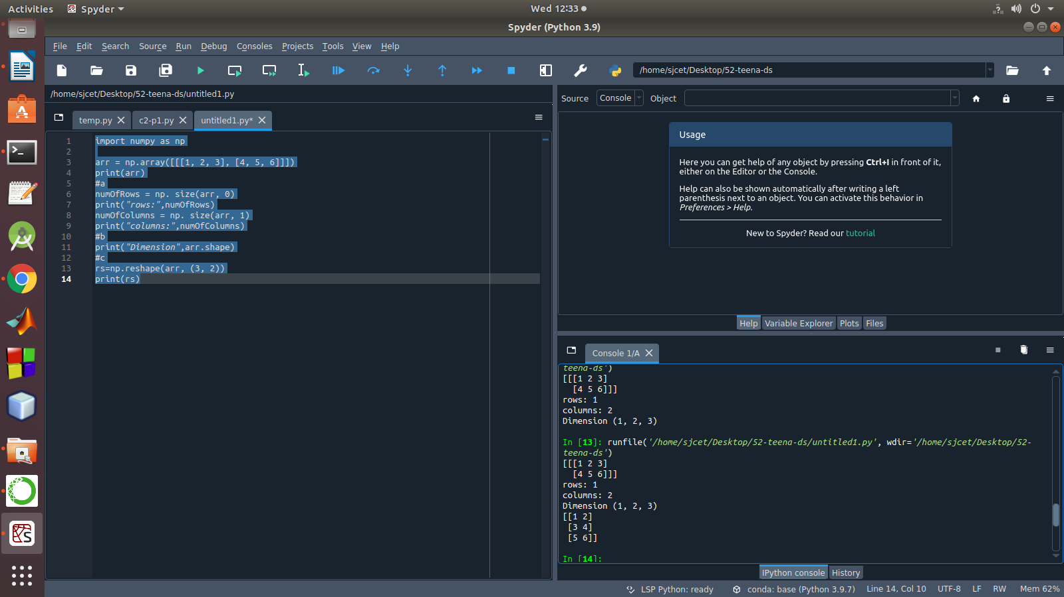

3. Familiarize with the functions to create
a) an uninitialized array
b) array with all elements as 1,
c) all elements as 0

PROGRAM:
import numpy as np
x = np.empty([2,2])
print("uninitialized array:",x)
y=np.full([2,2],1)
print("array with all elements as 1:",y)
z=np.full([2,2],0)
print("array with all elements as 0:",z)

OUTPUT:
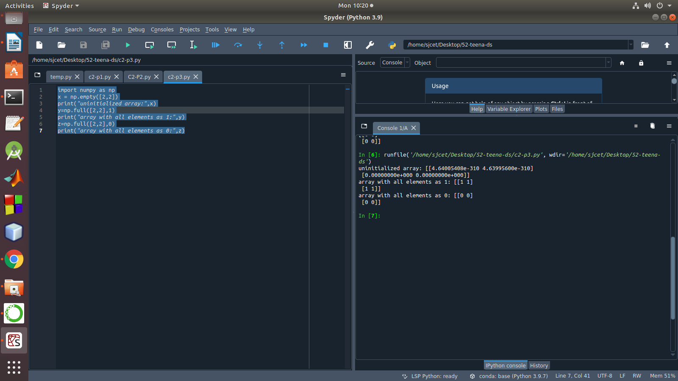

4. Create an one dimensional array using arange function containing 10 elements.
Display
a. First 4 elements
b. Last 6 elements
c. Elements from index 2 to 7

PROGRAM:
import numpy as np
a=np.arange(1,11,1)
print(a)
a1=a[:4]
print("First 4 elements:",a1)
a2=a[6:]
print("Last 6 Elements:",a2)
a3=a[2:7]
print("Elements from index 2 to 7:",a3)
OUTPUT:
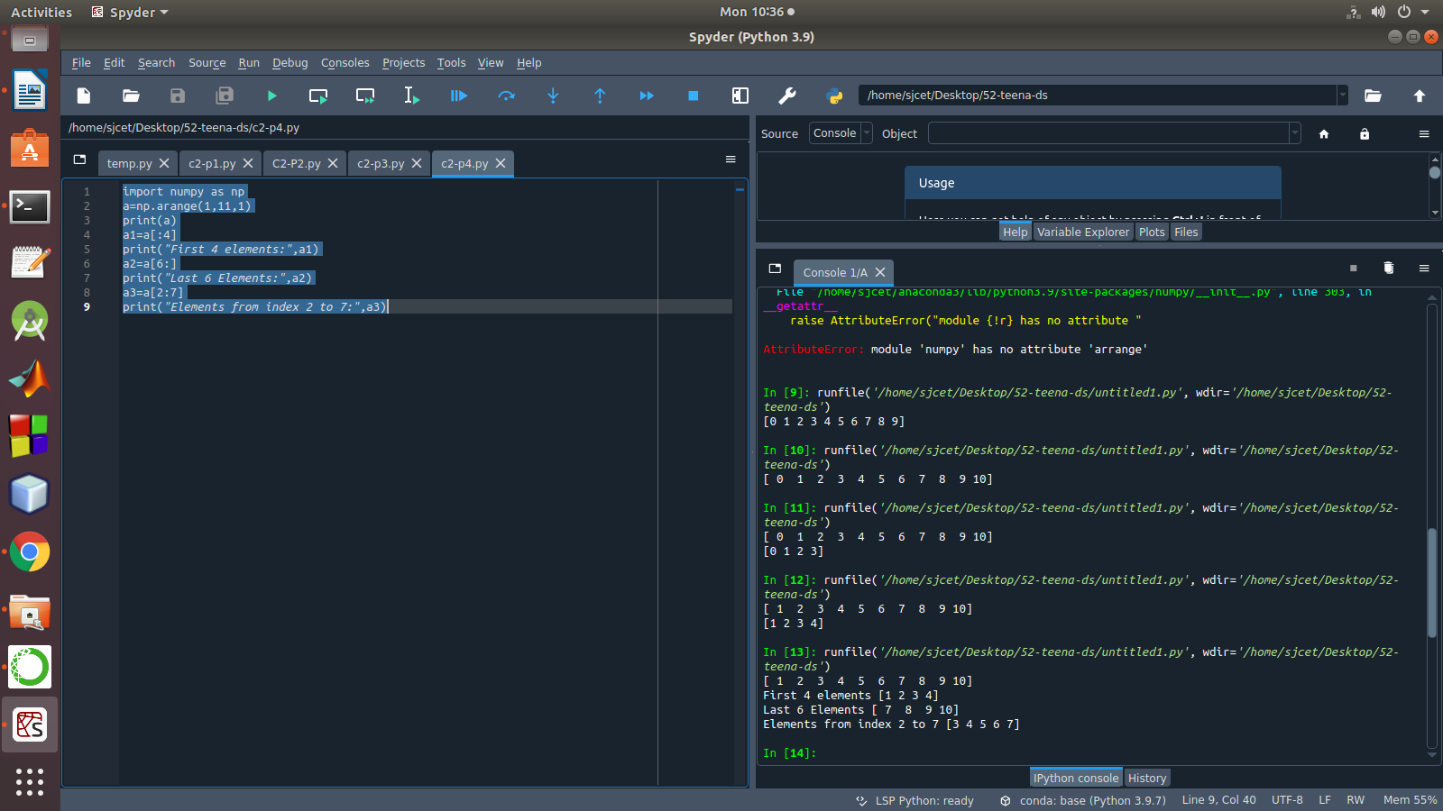

5. Create an 1D array with arange containing first 15 even numbers as elements
a. Elements from index 2 to 8 with step 2(also demonstrate the same
using slice function)
b. Last 3 elements of the array using negative index
c. Alternate elements of the array
d. Display the last 3 alternate elements

PROGRAM:
import numpy as np
a=np.arange(1,16,1)
print("Arange:",a[2:8])
arr=np.array([1,2,3,4,5,6,7,8,9,10,11,12,13,14,15])
print("Slicing:",arr[2:8])
print("Last 3 Elements:",a[-3:])
a1=a=np.arange(1,16,2)
print("Alternate Numbers:",a1)
print("Last 3 Alternate Numbers:",a1[-3:])

OUTPUT:
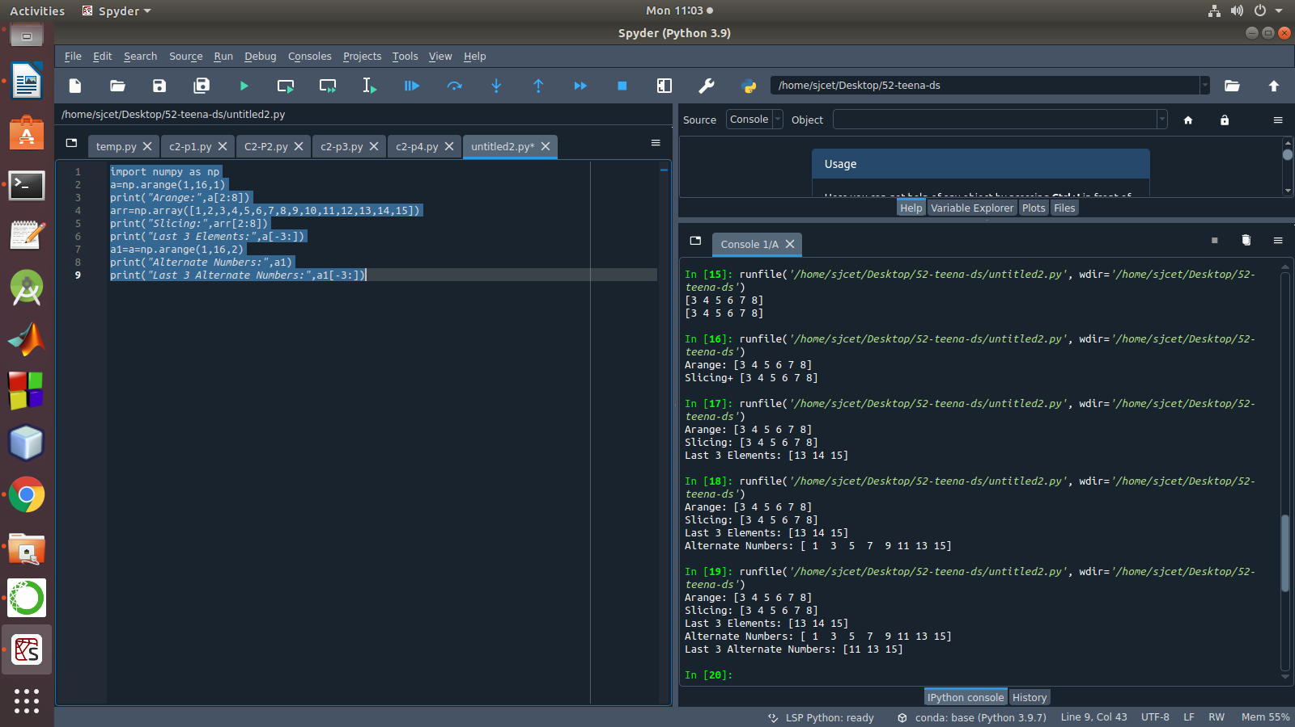

6. Create a 2 Dimensional array with 4 rows and 4 columns.
a. Display all elements excluding the first row
b. Display all elements excluding the last column
c. Display the elements of 1 st and 2 nd column in 2 nd and 3 rd row
d. Display the elements of 2 nd and 3 rd column
e. Display 2 nd and 3 rd element of 1 st row
f. Display the elements from indices 4 to 10 in descending order(use
–values)
PROGRAM:
import numpy as np
a = np.array([[1, 2, 3,4], [4, 5, 6,5], [7, 8, 9,6], [10, 11, 12,7]])
print(a)
print("elements excluding the first row:\n",a[1:])
print("elements excluding the first Column:\n",a[:,:3])
print("elements of 2 nd and 3 rd column:\n",a[:,1:3])
print("2 nd and 3 rd element of 1 st row:",a[0,1],a[0,2])
OUTPUT:
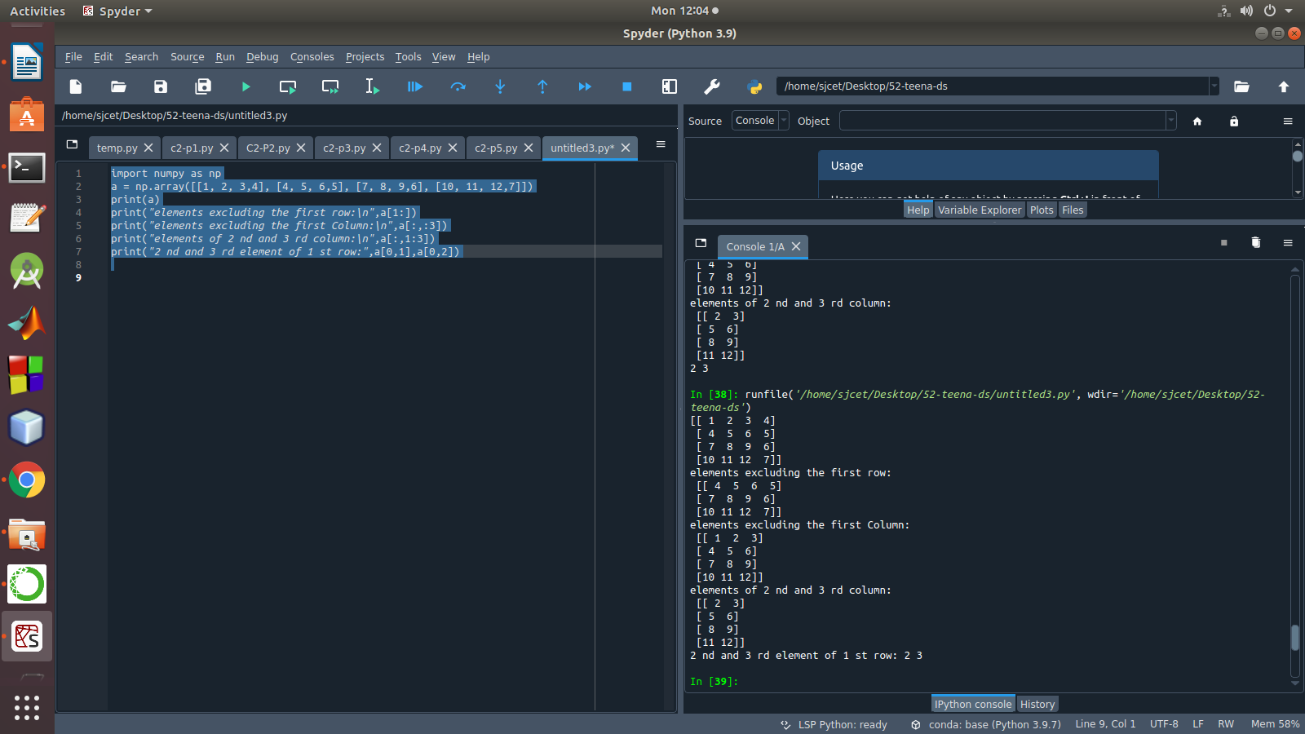

7. Create two 2D arrays using array object and
a. Add the 2 matrices and print it
b. Subtract 2 matrices
c. Multiply the individual elements of matrix
d. Divide the elements of the matrices
e. Perform matrix multiplication
f. Display transpose of the matrix
g. Sum of diagonal elements of a matrix

PROGRAM:
import numpy as np
a = np.array([[1, 2, 3,4], [4, 5, 6,5], [7, 8, 9,6], [10, 11, 12,7]])
b = np.array([[1, 2, 3,4],[7, 8, 9,6] , [4, 5, 6,5], [10, 11, 12,7]])
print("Addition:\n",np.add(a,b))
print("Subtraction:\n",np.subtract(a,b))
print("Multiply the individual elements:\n",np.multiply(a,b))
print("Divide:\n",np.divide(a,b))
print("Multiply:\n",np.dot(a,b))
print("Transpose:\n",np.transpose(a))
print("Sum of Diagonal Elements:\n",np.trace(a))

OUTPUT:
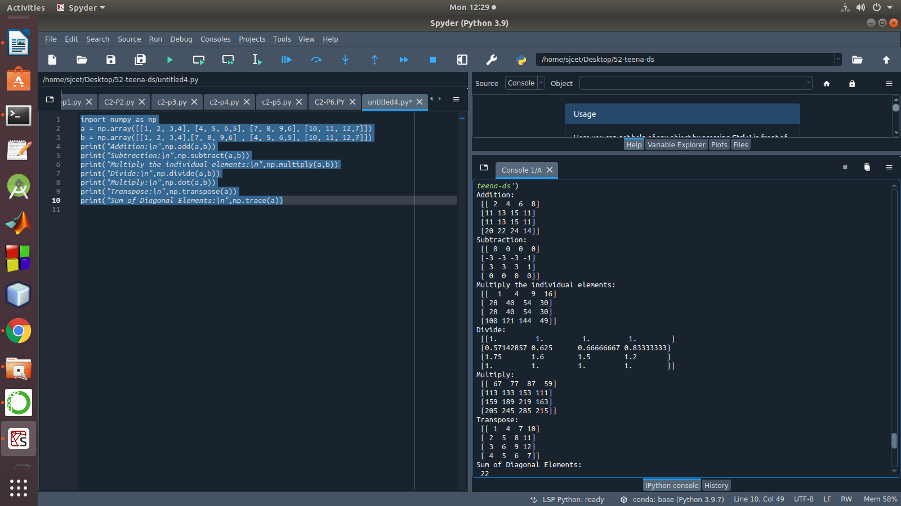

8. Demonstrate the use of insert() function in 1D and 2D array.
PROGRAM:

import numpy as np
arr1 = np.arange(10, 16)
print("1D ARRAY ")
print("The array is: ", arr1)
obj = 2
value = 40
arr = np.insert(arr1, obj, value, axis=None)
print("After inserting the new array is: ")
print(arr)
print("Shape of the new array is : ", np.shape(arr))
print("2D ARRAY ")
arr1 = np.array([(1, 2, 3), (4, 5, 6), (7, 8, 9), (50, 51, 52)])
print("The array is: ")
print(arr1)
print("The shape of the array is: ", np.shape(arr1))
a = np.insert(arr1, 1, [[50], [100], ], axis=0)
print("New array is : ")
print(a)
print("Shape of the array is: ", np.shape(a))

OUTPUT
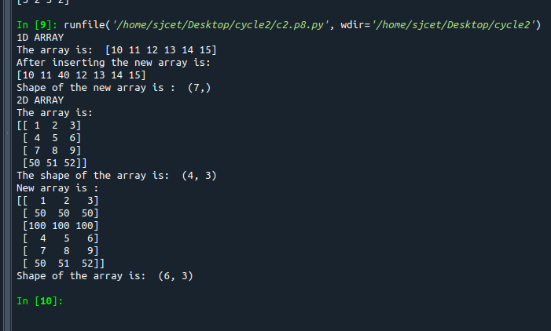

9. Demonstrate the use of diag() function in 1D and 2D array.
PROGRAM

import numpy as np
a= np.array([[3, 6,7,8]])
b=np.array([[3, 6,8,7], [4, 2,1,0],[3,1,3,3],[1,1,2,2]])
x=np.diag(a)
y=np.diag(b)
print(x)
print(y)

OUTPUT
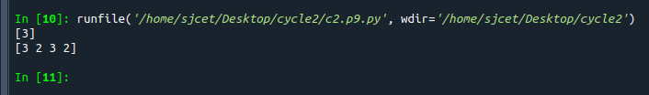

10. Demonstarte the use of append() function in 1D and 2D array.

PROGRAM

import numpy as np
a = np.array([[1,2,3],[4,5,6]])
b=np.array([1,2,3])
print("First array:")
print (a)
print("Second array")
print(b)
print ("\n")
print ("Append elements to array:")
print (np.append(a, [7,8,9]))
print (np.append(b, [7,8,9]))

OUTPUT
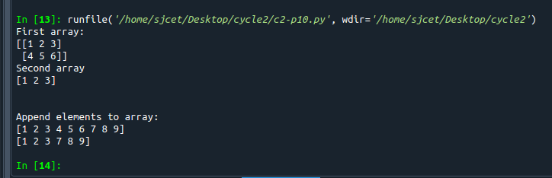

11. Demonstarte the use of sum() function in 1D and 2D array.

PROGRAM
import numpy as np
a=np.array([0.4,0.5])
b=np.sum(a)
print (b)

OUTPUT
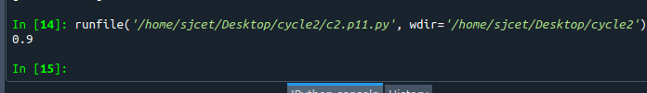

12.Create a 1 Dimensional array .Display the elements from indices 4 to 10 in descending order

PROGRAM
import numpy as np
#create numpy array
a = np.array([1,2,8,9,3,4,5,6,7])
print(a)
array_copy = np.sort(a)[::-1]
print(array_copy[4:10])

OUTPUT
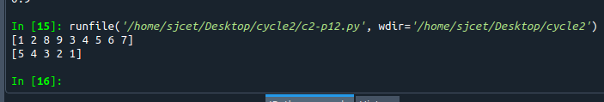

PART:2
1. Create a square matrix with random integer values(use randint()) and use
appropriate functions to find:
i) inverse
ii) rank of matrix
iii) Determinant
iv) transform matrix into 1D array
v) eigen values and vectors

PROGRAM
import numpy as np
from numpy import random
x=random.randint(100, size=(3,3))
inv = np.linalg.inv(x)
print("Matrix:\n",x)
print("Inverse:\n",inv)
rank=np.linalg.matrix_rank(x)
print("Rank:",rank)
print ("Determinant:",np.linalg.det(x))
arr = x.flatten()
print("Matrix to array:\n",arr)
w, v = np.linalg.eig(x)
print("Eigen value:\n",w)
print("Eigen Vector:\n",v)

OUTPUT
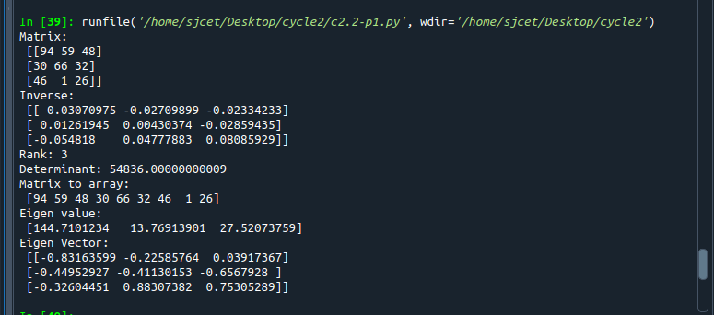
2. Create a matrix X with suitable rows and columns
i) Display the cube of each element of the matrix using different methods
(use multiply(), *, power(),**)
ii) Display identity matrix of the given square matrix.
iii) Display each element of the matrix to different powers.
iv) Create a matrix Y with same dimension as X and perform the operation X 2 +2Y

PROGRAM
import numpy as np

matrix=np.random.randint(0,10,4).reshape(2,2)
print("Display the cube of each element of the matrix using different methods (use multiply(), *, power(),**)")
x=np.power(matrix,3)
print("power()",x)

y=np.multiply(matrix,(matrix*matrix))
print("multiply()")
print(y)

z=matrix*matrix*matrix
print("**")
print(z)

cube=matrix*3
print("*")
print(cube)

print("Display identity matrix of the given square matrix.")
identity=np.identity(2,dtype=int)
print(identity)

print("Display each element of the matrix to different powers.")
dpow=np.power(matrix,matrix)
print(dpow)

print("Create a matrix Y with same dimension as X and perform the operation X^2 +2Y")
a=np.add((np.power(x,2)),(np.multiply(y,2)))
print(a)

OUTPUT
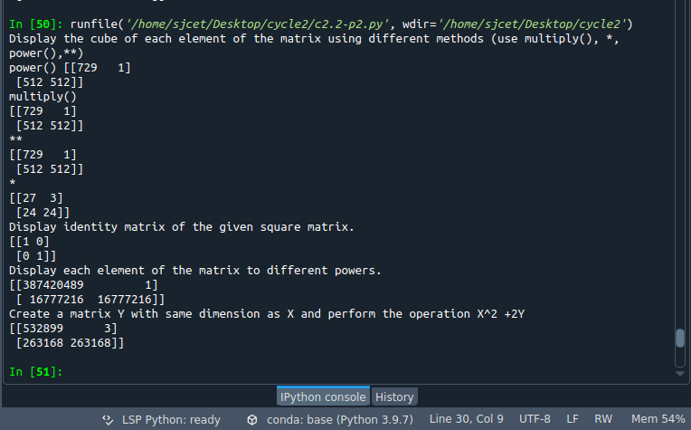

3. Multiply a matrix with a submatrix of another matrix and replace the same in larger
matrix.
PROGRAM
import numpy as np
A = np.array([[6, 1, 1,6,3],
[4, -2, 5,1,3],
[2, 8, 7,7,8],
[6, 1, 1,6,3],
[2, 8, 7,7,8]])
B=np.array([[2, 1, -2],
[3, 0, 1],
[1, 1, -1]])
C=A[:3, :3]
res = np.dot(B,C)
print(res)
A[:3,:3]=res[:3,:3]
print(A)

OUTPUT
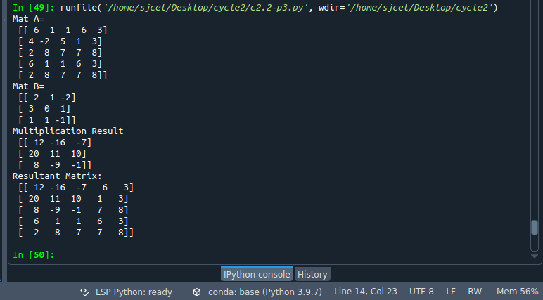

4. Given 3 Matrices A, B and C. Write a program to perform matrix multiplication of
the 3 matrices.
PROGRAM
import numpy as np
m1 = np.random.randint(20, size=(2, 2))
print(m1)
m2 = np.random.randint(20, size=(2, 2))
print(m2)
m3 = np.random.randint(20, size=(2, 2))
print(m3)
print("multiplication of the 3 matrices")
m4 = np.dot(m1,m2,m3)
print(m4)
OUTPUT
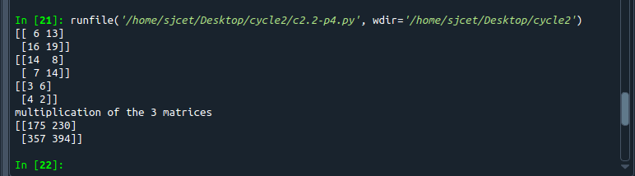

5.Write a program to check whether given matrix is symmetric or Skew Symmetric.

PROGRAM
import numpy as np
A = np.array([[6, 1, 1],
[4, -2, 5],
[2, 8, 7]])

inv=np.transpose(A)
neg=np.negative(A)
print ("Original Matrix\n",A)
print ("Traspose Matrix\n",inv)
print ("Negative Matrix\n",neg)
comparison = A == inv
comparison1 = inv== neg
equal_arrays = comparison.all()
skew=comparison1.all()
if equal_arrays :
print("Given Matrix is Symmetric")
else:
print("Given Matrix is not Symmetric")

if skew:
print("Given Matrix is Skew Symmetric")
else:
print("Given Matrix is Not Skew Symmetric")

OUTPUT
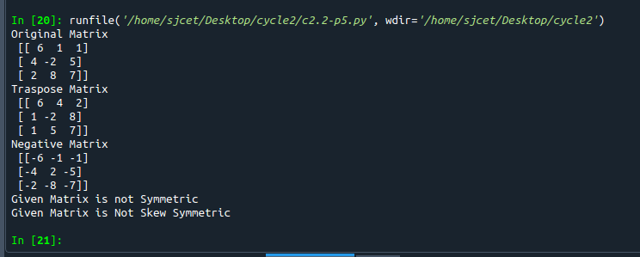

6. Write a program to find out the value of X using solve(), given A and b as above
PROGRAM
import numpy as np
A = np.array([[2, 1, -2],
[3, 0, 1],
[1, 1, -1]])
b=np.array([[3],
[5],
[-2]])
inv=np.linalg.inv(A)
x=np.linalg.solve(inv,b)
print(x)

OUTPUT
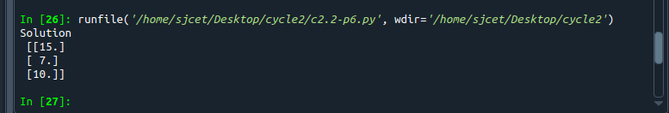

7. Write a program to perform the SVD of a given matrix. Also reconstruct the given matrix
from the 3 matrices obtained after performing SVD.

PROGRAM
from numpy import array
from scipy.linalg import svd
from numpy import diag
from numpy import zeros
# define a matrix
A = array([[1, 2], [3, 4], [5, 6]])
print(A)
# SVD
U, s, VT = svd(A)
print("first" ,U)
print("second",s)
print("3rd" ,VT)
Sigma = zeros((A.shape[0], A.shape[1]))
# populate Sigma with n x n diagonal matrix
Sigma[:A.shape[1], :A.shape[1]] = diag(s)
# reconstruct matrix
B = U.dot(Sigma.dot(VT))
print(B)

OUTPUT
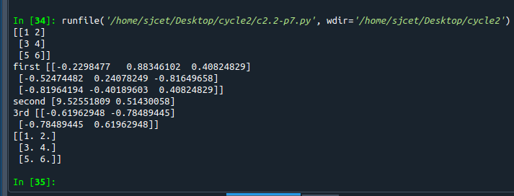

CYCLE-3
1.Sarah bought a new car in 2001 for $24,000. The dollar value of her car changed each year as shown in
the table below.
Value of Sarah&#39;s Car
Year Value
2001 $24,000
2002 $22,500
2003 $19,700
2004 $17,500
2005 $14,500
2006 $10,000
2007 $ 5,800
Represent the following information using a line graph with following style properties
• X- axis - Year
Y –axis - Car Value
• title –Value Depreciation (left Aligned)
• Line Style dashdot and Line-color should be red
• point using * symbol with green color and size 20

PROGRAM
import matplotlib.pyplot as plt
import numpy as np

xpoints = np.array([2001,2002,2003,2004,2005,2006, 2007])
ypoints = np.array([24000, 22500,19700,17500,14500,10000,5800])

plt.title("Value Depreciation",loc='left')
plt.xlabel("Year")
plt.ylabel("Car Value")
plt.plot(xpoints, ypoints,marker = '*', ms = 20, mfc = 'g',ls = '-.',color = 'r')
plt.show()

OUTPUT
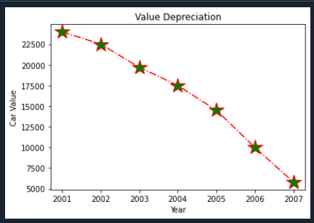

2.Following table gives the daily sales of the following items in a shop
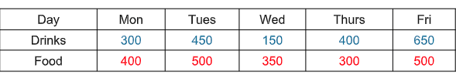

Use subplot function to draw the line graphs with grids(color as blue and line style dotted) for the
above information as 2 separate graphs in two rows
a) Properties for the Graph 1:
• X label- Days of week
• Y label-Sale of Drinks
• Title-Sales Data1 (right aligned)
• Line –dotted with cyan color
• Points- hexagon shape with color magenta and outline black
b) Properties for the Graph 2:
• X label- Days of Week
• Y label-Sale of Food
• Title-Sales Data2 ( center aligned)
• Line –dashed with yellow color
• Points- diamond shape with color green and outline red

PROGRAM
import matplotlib.pyplot as plt
import numpy as np

#plot 1:
x = np.array(['Mon', 'Tues',' Wed', 'Thurs',' Fri'])
y = np.array([300,450,150,400,650])

plt.subplot(2, 1, 1)
plt.plot(x,y,ls = ':',color = 'c',marker = 'h',mfc = 'm',mec = 'k')
plt.grid()
plt.xlabel("Days of Week")
plt.ylabel("Sale of Drinks")
plt.title("Sales Data1",loc='right')

#plot 2:
x = np.array(['Mon','Tues',' Wed', 'Thurs',' Fri'])
y = np.array([400,500,350,300,500])

plt.subplot(2, 1, 2)
plt.xlabel("Days of Week")
plt.ylabel("Sale of Food")
plt.title("Sales Data2",loc='right')
plt.plot(x,y,ls = '-',color = 'y',marker = 'D',mfc = 'g',mec = 'r')
plt.grid()
plt.show()

OUTPUT
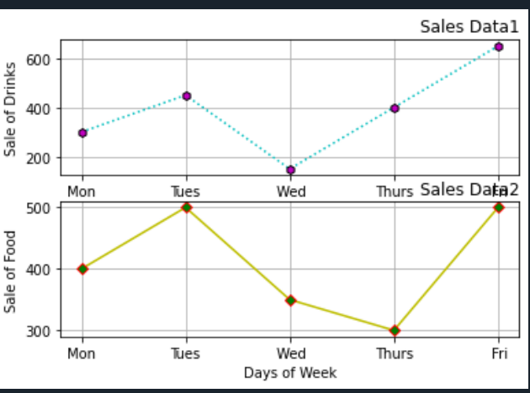

3. Create scatter plot for the below data:(use Scatter function)
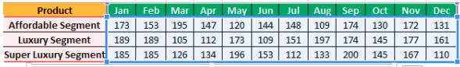
Create scatter plot for each Segment with following properties within one graph
• X Label- Months of Year with font size 18
• Y-Label- Sales of Segments
• Title –Sales Data
• Color for Affordable segment- pink
• Color for Luxury Segment- Yellow
• Color for Super luxury segment-blue

PROGRAM
import matplotlib
import matplotlib.pyplot as plt
import numpy as np
plt.title("Sales Data")
plt.xlabel("Months of Year",size=18)
plt.ylabel("Sales of Segments")
#day one, the age and speed of 13 cars:
x = np.array(['Jan','Feb','Mar','Apr','May','Jun','Jul','Aug','Sep','Oct','Nov','Dec'])
y = np.array([173,153,195,147,120,144,148,109,174,130,172,131])
plt.scatter(x, y,color = 'hotpink')

#day two, the age and speed of 15 cars:
x = np.array(['Jan','Feb','Mar','Apr','May','Jun','Jul','Aug','Sep','Oct','Nov','Dec'])
y = np.array([189,189,105,112,173,109,151,197,174,145,177,161])
plt.scatter(x, y,color = 'y')

#day two, the age and speed of 15 cars:
x = np.array(['Jan','Feb','Mar','Apr','May','Jun','Jul','Aug','Sep','Oct','Nov','Dec'])
y = np.array([185,185,126,134,196,153,112,133,200,145,167,110])
plt.scatter(x, y,color = 'b')

plt.show()

OUTPUT
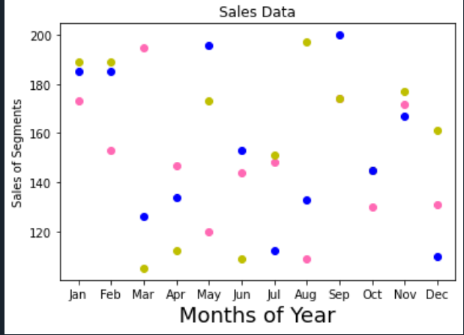

4. Display the above data using multiline plot( 3 different lines in same graph)
• Display the description of the graph in upper right corner(use legend())
• Use different colors and line styles for 3 different lines

PROGRAM
#Three lines to make our compiler able to draw:

import matplotlib.pyplot as plt
import numpy as np

x = np.array(['Jan','Feb','Mar','Apr','May','Jun','Jul','Aug','Sep','Oct','Nov','Dec'])
y1 = np.array([173,153,195,147,120,144,148,109,174,130,172,131])
y2= np.array([189,189,105,112,173,109,151,197,174,145,177,161])
y3= np.array([185,185,126,134,196,153,112,133,200,145,167,110])

plt.plot(x,y1,label = "Affordable Segment",ls=':')
plt.plot(x,y2,label = "Luxuary Segment",ls="-")
plt.plot(x,y3,label = "Super Luxuary Segment",ls="-.")
plt.legend()
plt.show()
#Two lines to make our compiler able to draw:

OUTPUT
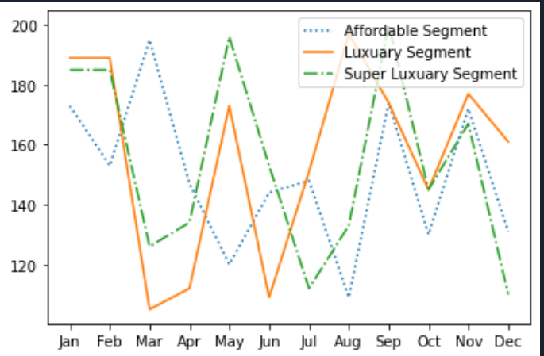

6.100 students were asked what their primary mode of transport for getting to school was. The results of his survey are recorded in the table below. Construct a bar graph representing this information.
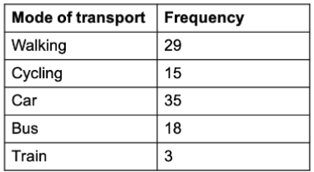

Create a bar graph with
• X axis -mode of Transport and Y axis ‘frequency’
• Provide appropriate labels and title
• Width .1, color green

PROGRAM:
import matplotlib.pyplot as plt
import numpy as np

x = np.array(["Walking", "Cycling", "Car", "bus","Train"])
y = np.array([29, 15, 35, 18,3])
plt.title("Mode of Transport")
plt.xlabel("Mode of Transport")
plt.ylabel("frequency")
plt.bar(x, y, width = 0.1,color="g")
plt.show()

OUTPUT:

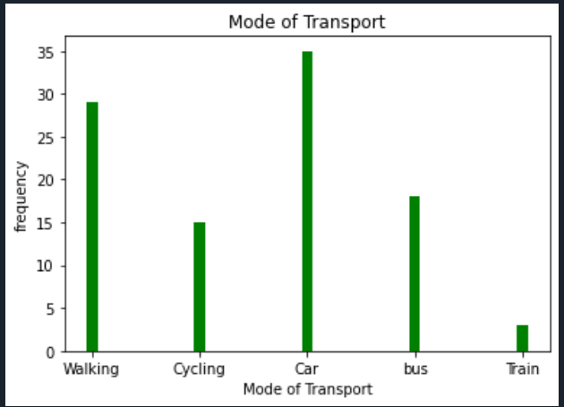

6.We are provided with the height of 30 cherry trees.
The height of the trees (in inches): 61, 63, 64, 66, 68, 69, 71, 71.5, 72, 72.5, 73, 73.5, 74, 74.5, 76, 76.2,76.5, 77, 77.5, 78, 78.5, 79, 79.2, 80, 81, 82, 83, 84, 85, 87.Create a histogram with a bin size of 5

PROGRAM:
import matplotlib.pyplot as plt
x = [61, 63, 64, 66, 68, 69, 71, 71.5, 72, 72.5, 73, 73.5, 74, 74.5, 76, 76.2,
76.5, 77, 77.5, 78, 78.5, 79, 79.2, 80, 81, 82, 83, 84, 85, 87]
plt.hist(x, bins=5)
plt.show()

OUTPUT:
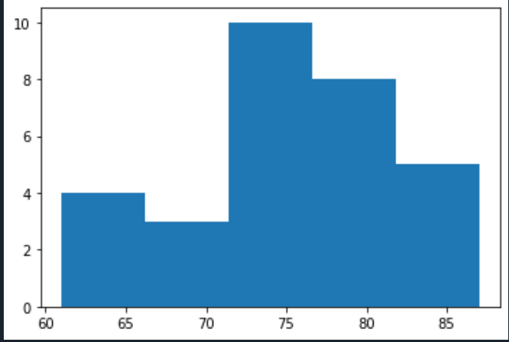

CYCLE-4
1. Use appropriate functions in pandas to display
(i) Shape of the data set
(ii) First 5 and last five rows of data set(head and tail)
(iii) Size of dataset
(iv) No:of samples available for each variety
(v) Description of the data set( use describe)

PROGRAM:
import numpy as np
import matplotlib.pyplot as plt
import seaborn as sns
import pandas as pd
iris=pd.read_csv("iris.csv")
print("shape:",iris.shape)
print("*********")
print("First five rows")
print(iris.head())
print("*********")
print("last five rows")
print(iris.tail())
print("*********")
print("Size:",iris.size)
print("*********")
print("no of samples available for each type")
print(iris["variety"].value_counts())
print("*********")
print("columns",iris.columns)
print("*********")
print(iris.describe())

OUTPUT:

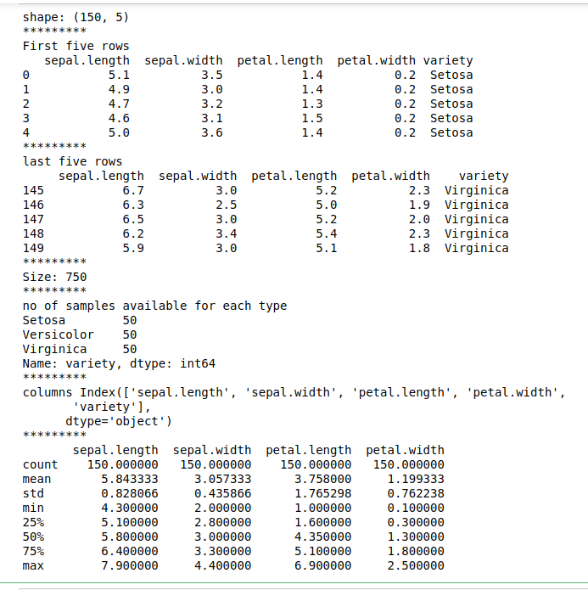

2. Use pairplot() function to display pairwise relationships between attributes. Try
different kind of plots {‘scatter’, ‘kde’, ‘hist’, ‘reg’} and different kind of markers.

PROGRAM:
import numpy as np
import matplotlib.pyplot as plt
import seaborn as sns
import pandas as pd
sns.set_style("whitegrid")
sns.pairplot(iris,hue="variety",height=3, kind = 'kde');
sns.pairplot(iris,hue="variety",height=3, kind = 'scatter');
sns.pairplot(iris,hue="variety",height=3, kind = 'hist');
sns.pairplot(iris,hue="variety",height=3, kind = 'reg');
plt.show()

OUTPUT:

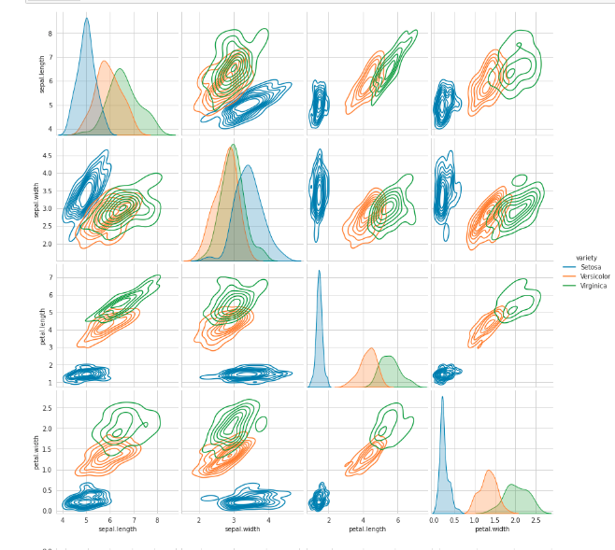

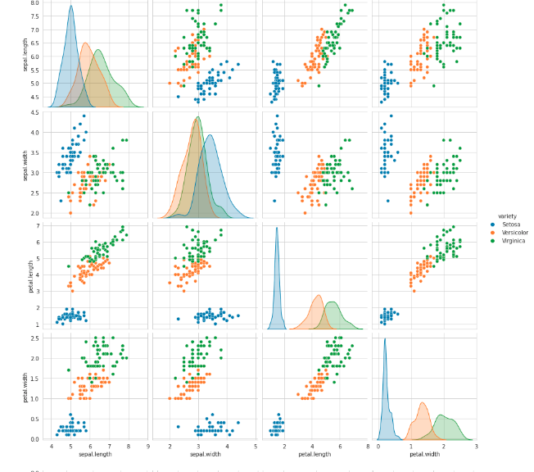

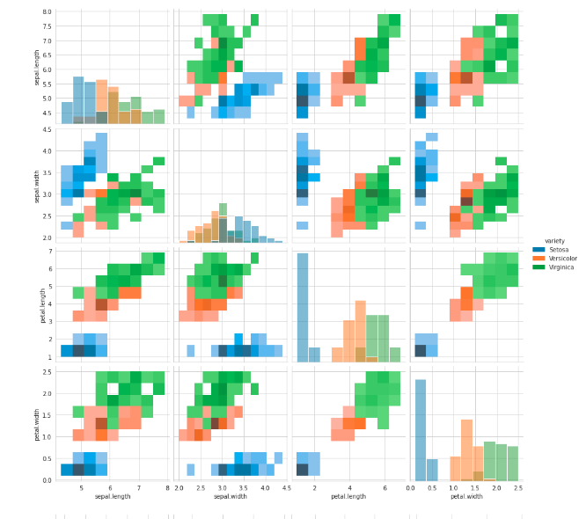

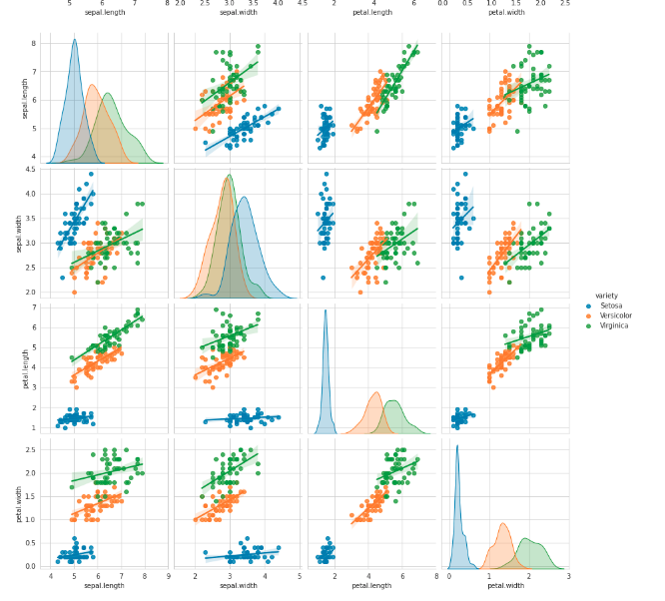

3. using the iris data set,get familiarize with functions:
1)displot()
2) histplot()
3) relplot()
PROGRAM:

1)displot()
import numpy as np
import matplotlib.pyplot as plt
import seaborn as sns
import pandas as pd
col=['sepal_length','sepal_width','petal_length','petal_width','type']
df = sns.load_dataset('iris')
df.head()
sns.displot(x = 'petal_length',kde=True,bins = 5 , data =df)

OUTPUT:
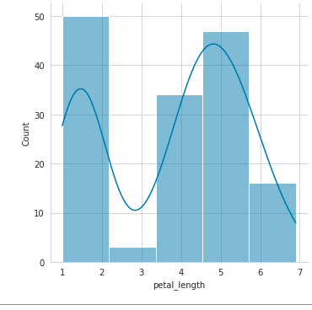

2) histplot()

PROGRAM:
import numpy as np
import pandas as pd
import seaborn as sns

# Load dataset
dataset = sns.load_dataset("iris")
# Plot histogram
sns.histplot(data = dataset, x = "sepal_length", kde = True)

OUTPUT:

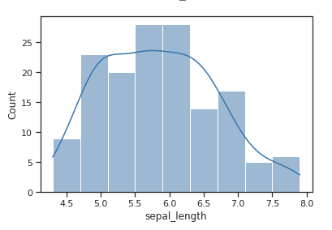

3) relplot()

PROGRAM:
import seaborn as sns
sns.set(style ="ticks")
dataset = sns.load_dataset('iris')
col=['sepal_length','sepal_width','petal_length','petal_width','type']
sns.relplot(x ="sepal_length", y ="petal_width", data = dataset)

OUTPUT:


